For Immediate Release Contact: Katrina Blomdahl – 202-637-3921
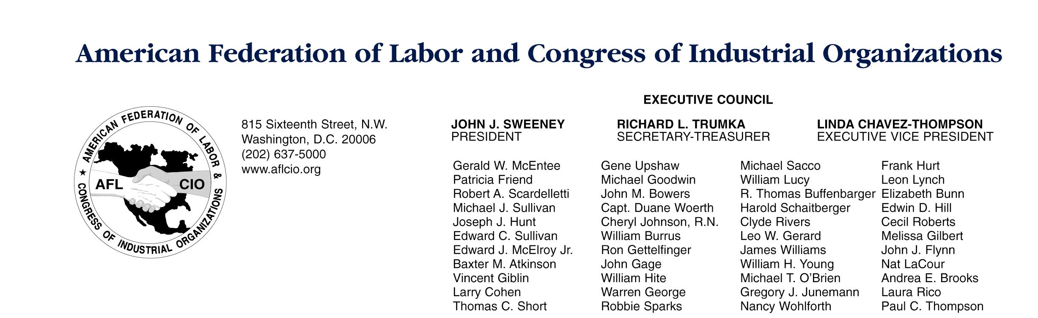
Steve Smith – 202-637-5018

AFL-CIO President John Sweeney
On Today’s Bush Labor Board Decision That Will Strip Workers of Union Rights
October 3, 2006

Today, the National Labor Relations Board, dominated by Bush administration appointees, announced a decision which welcomes employers to strip millions of workers of their right to have a union by reclassifying them as “supervisors” – in name only. Supervisors do not have protected rights under the National Labor Relations Act to improve their lives by forming and joining unions.

The case - - Oakwood Healthcare, Inc. -- was one of three cases announced today by the NLRB in the aftermath of the Supreme Court decision in NLRB v. Kentucky River Community Care. The Oakwood case is the lead case, and sets a broad new standard which will determine whether millions of workers are “supervisors.”

While the Supreme Court decision cracks open the door to a redefinition of who is a supervisor, the decision by the NLRB virtually kicks it in. In fact, according to NLRB members Liebman and Walsh in their dissent regarding the Oakwood case, “Today’s decision threatens to create a new class of workers under Federal labor law: workers who have neither the genuine prerogatives of management, nor the statutory rights of ordinary employees. In that category may fall most professionals (among many other workers), who by 2012 could number almost 34 million, accounting for 23.3 percent of the workforce.” An Economic Policy Institute study has found that up to 8 million workers could be affected immediately by the decisions.

Today’s decision is the latest in the Bush-appointed NLRB’s legal maneuvering to deny as many workers as possible their basic right to have a voice on the job and improve their living standards through their union. Over the last several years, the NLRB has chipped away at that right by limiting the eligibility of disabled workers, teaching assistants, temporary workers and others to join unions. Now, at the very time middle class workers need more help, not less, the NLRB is taking a broad swing.

The immediate implications of the Oakwood Healthcare Inc. case are devastating to workers in the health care industry and potentially in other industries where professional employees direct or assign the work of others. The Board rewrote broad definitions of supervisory duties, such as assigning work, responsibility to direct and use of independent judgment. In fact, the Board decided that if an employee spends as little as 10 to 15 percent of their time performing

supervisory functions that they will be considered to be supervisors, and thus likely stripped of their right to have a union.

The other two cases released today, on Golden Crest Healthcare Center and Croft Metals, Inc., were applications of the new standard set forth in the Oakwood decision. While in both these cases the Board decided that the workers were not considered supervisors, this provides little indication of how future cases will be decided under the new standard.

It is a sad day for every American who works to put food on the table and gas in their cars, when the rights they count on can be cynically eviscerated by a Labor Board that is informed more by political ideology than sound legal analysis.

The NLRB should protect workers’ rights -- not eliminate them. If the Administration expects us to take this quietly, they’re mistaken. Over the next week, working people will be coming together in the streets in cities across the nation to make sure everyone knows the Bush Administration is slashing workers’ right to have a voice on the job.

###

